

To Supply Leftover Food to Poor

**TEAM ID:** **NM2025TMID22581**

**TEAM MEMBERS:**

**Team Leader** : Vijayalakshmi M

**Email** : [23bsct266vijayalakshmim@skacas.ac.in](mailto:23bsct266vijayalakshmim@skacas.ac.in)

**NM ID :** 94F9F41C51E1575B361452C9A6FD7162

**Team Member 1**: Sudarshan M S

**Email** : [23bsct264sudarsanms@skacas.ac.in](mailto:23bsct264sudarsanms@skacas.ac.in)

**NM ID** :A049248BD5BF37FA0BE41607725EA4FC

**Team Member 2**: Sunil Kumar T

**Email**  : [23bsct265sunilkumart@skacas.ac.in](mailto:23bsct265sunilkumart@skacas.ac.in)

**NM ID** : A5FBB1D138D0ABB83904333C92FC55B2

**1.INTRODUCTION**

**1.1 PROJECT OVERVIEW**

This project aims to build a Salesforce-based solution to collect, track, and distribute leftover food from restaurants, hotels, events, and households to those in need. By using Salesforce CRM, volunteers, donors, and NGOs can collaborate on a single platform to reduce food waste and ensure timely delivery of food to poor and homeless communities. The system will capture donor details, available food quantity, drop-off points, volunteers' availability, and distribution details, helping to create a structured and transparent process.

**2. Objectives**

At the heart of FoodConnect lies a mission to address food waste and hunger while empowering communities through efficient technology. Our objectives are crafted to

deliver measurable impact and foster a culture of sharing and accountability.:

Business Goals:

**A. Reduce Food Waste**: Redirect surplus food from donors such as restaurants, grocery stores, and events to those in need, minimizing wastage and maximizing its value.

**B. Combat Hunger:** Build a reliable network that connects food suppliers with non-profits,shelters, and underserved communities, ensuring timely access to nutritious meals.

**C. Streamline Operations**: Simplify and enhance volunteer coordination, task management,and communication to create a seamless experience for all stakeholders.

**D. Promote Transparency and Accountability**: Leverage technology to provide clear tracking,reporting, and insights into food collection, distribution, and impact.

**Specific Outcomes:**

**a. A Comprehensive Web Application:**

● Manage venues and drop-off points efficiently.

● Enable real-time task assignment and tracking for volunteers.

● Provide robust reporting and analytics dashboards to measure performance and impact.

**b. Intelligent Automation:**

● Automate the matching of food donations based on location, food type, and urgency to

optimize logistics and reduce delays.

**c. Enhanced Communication and Collaboration:**

● Foster real-time updates and coordination among donors, volunteers, and recipients through integrated communication tools.

**d. Data-Driven Insights:**

● Generate actionable insights to continuously improve operations, measure impact, and refine strategies for food redistribution.

**3. Salesforce Key Features and Concepts Utilized**

Food Connect Leverages the power of Salesforce to create an efficient ,Userfriendly platform that Streamlines food redistribution and Volunteer management. Here’s how we’ve utilized Salesforce features to bring the initiative to life

**1.Venues**: Store vital information about food donation locations , including address, capacity and contact details ,ensuring organized management of distribution points.

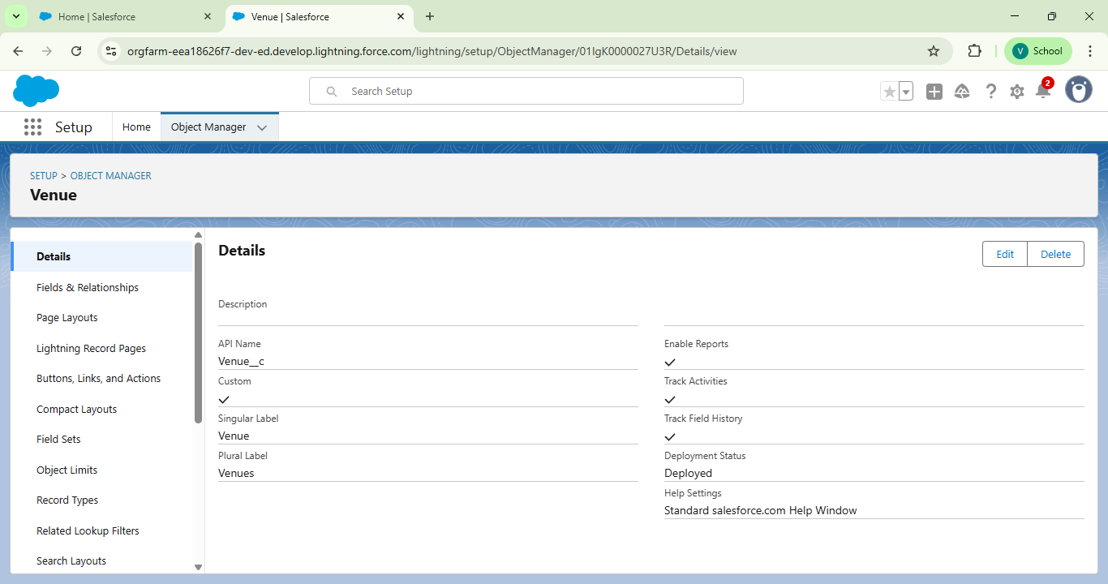

2**.Drop Off Points**: Record specific delivery locations, making it easier for volunteers to plan and execute tasks effectively.

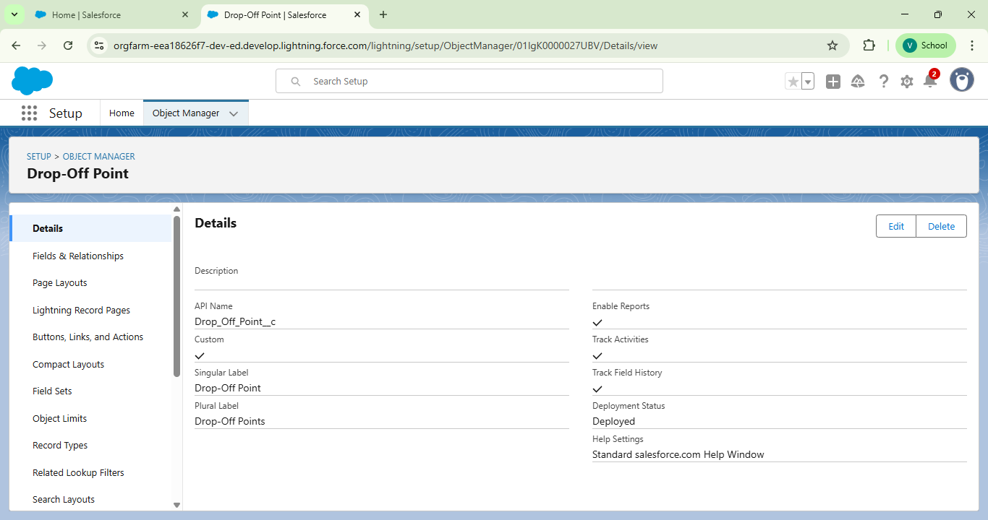

3.**Tasks:** Track and manage volunteer Assignments with fields for descriptions ,deadlines and responsible individuals.

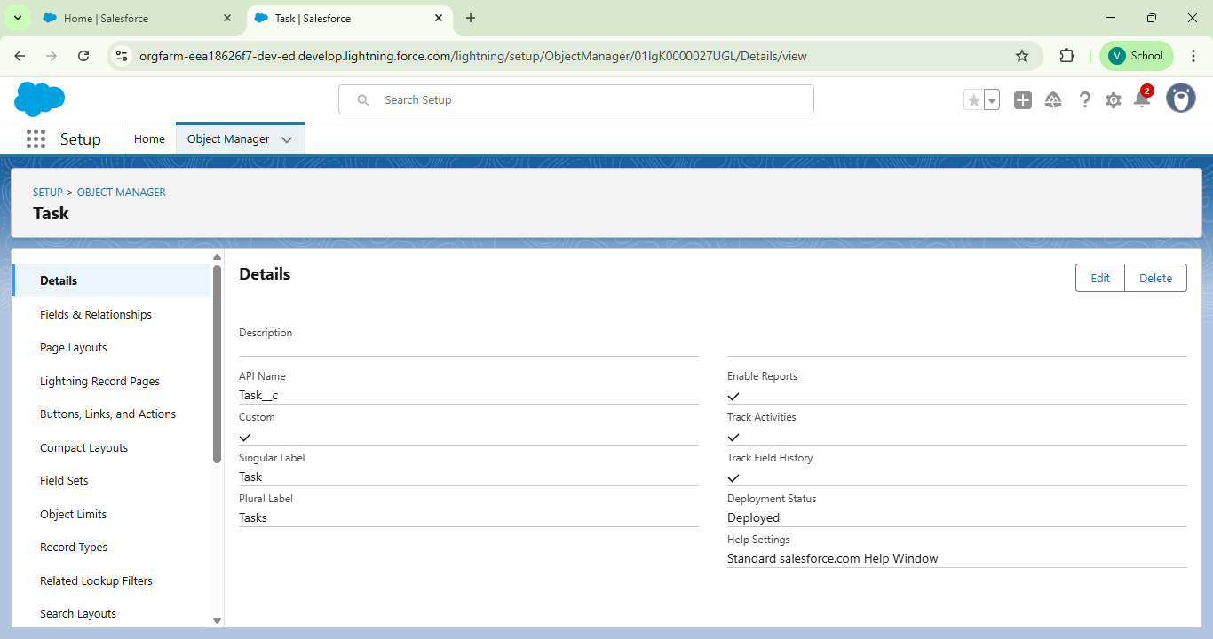

**4.Volunteers:** Maintain a centralized database of volunteers, including their contact details, availability and assigned tasks

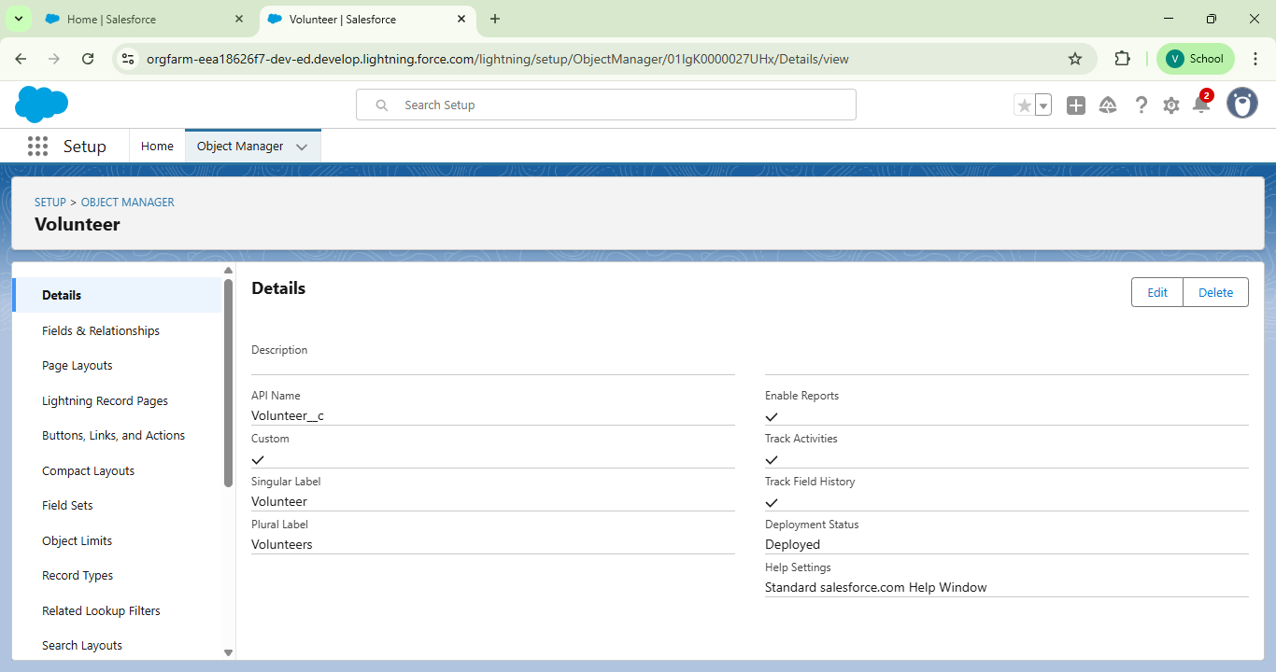

5.Execution Details:Document completed tasks , linking them to specific volunteers and drop off points for a detailed activity history.



**Relationships**

* Master-Detail Relationships: Create structured connections, such as linking tasks to their execution details, ensuring data consistency and logical organization.
* Lookup Relationships: Enable flexible associations, like connecting volunteers to drop-off points, allowing for dynamic task allocation based on location and availability.

**Automations and Workflows**

**1. Flows**: Automate processes like creating venue records or assigning tasks, guiding users through step-by-step workflows to ensure accuracy and efficiency

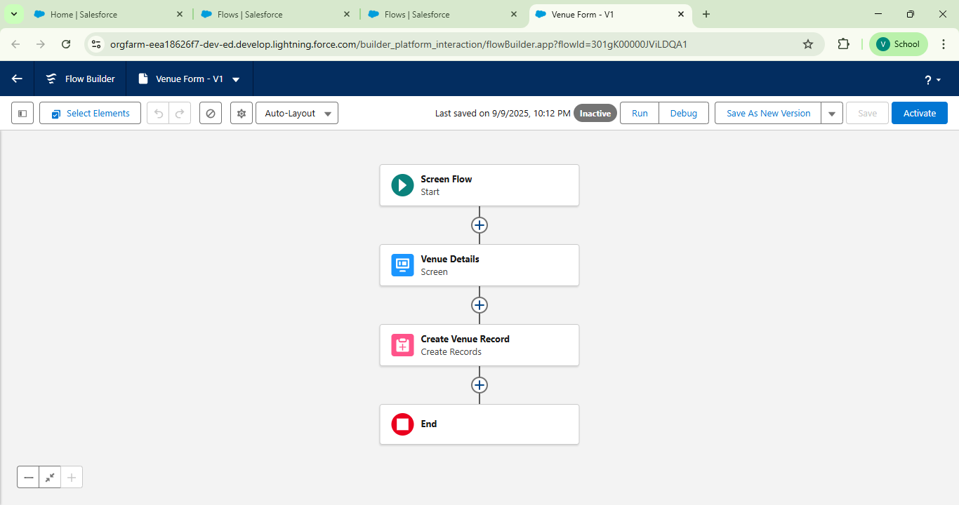

2. **Apex Triggers**: Implement custom logic, such as calculating distances between venues and volunteers, to optimize task assignments and reduce delivery times.

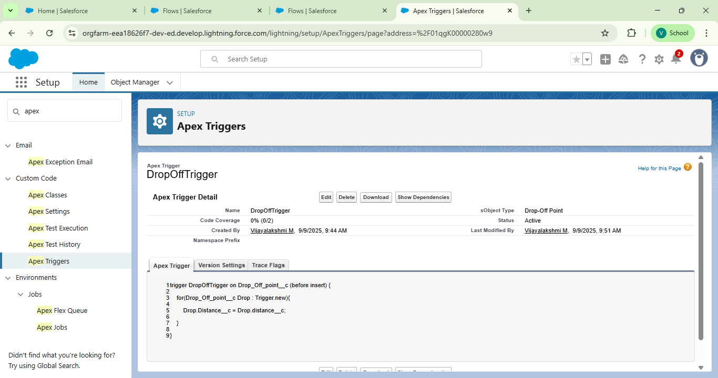

**Data Sharing and Security**

Profiles and Roles: Define user roles with tailored access levels to protect sensitive data while ensuring seamless collaboration.

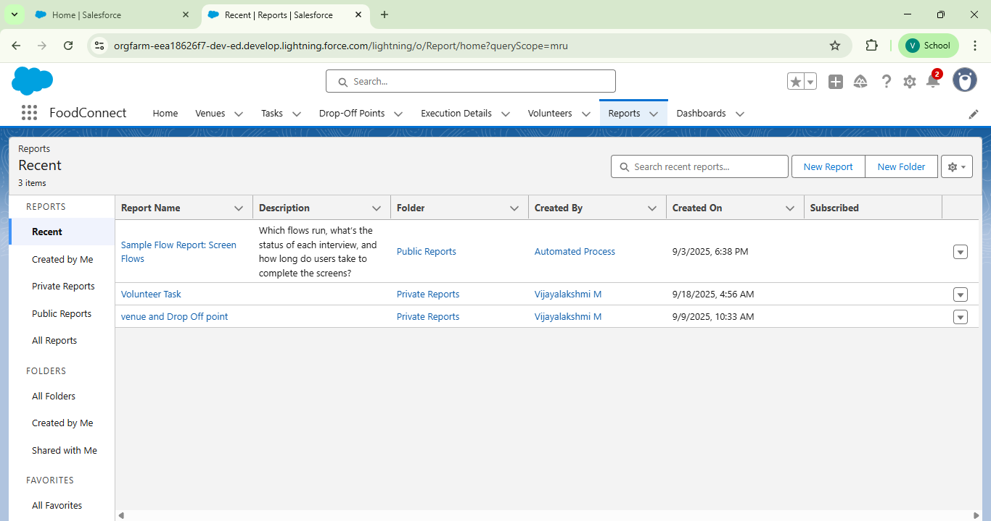

● **Dashboards:** Provide visual representations of key data, empowering stakeholders

to make informed decisions and track progress in real-time.

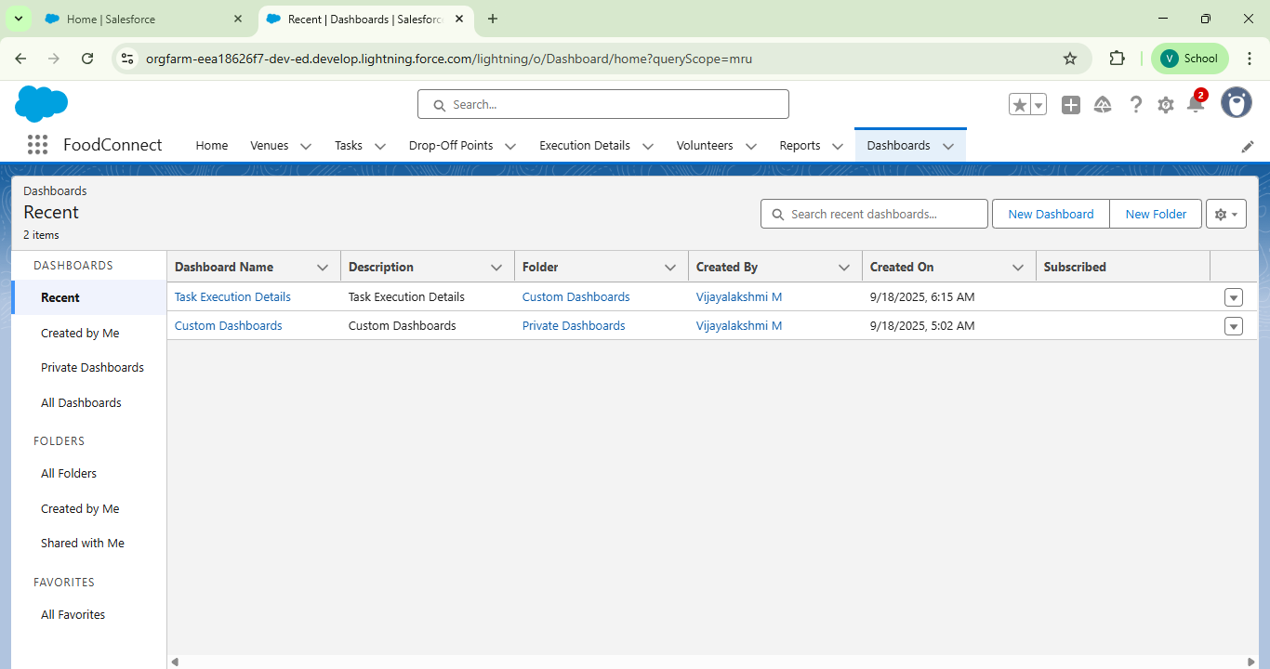

**User Experience Enhancements**

**● Lightning App**: Deliver a sleek, intuitive interface that simplifies navigation and ensures users can quickly access essential features.

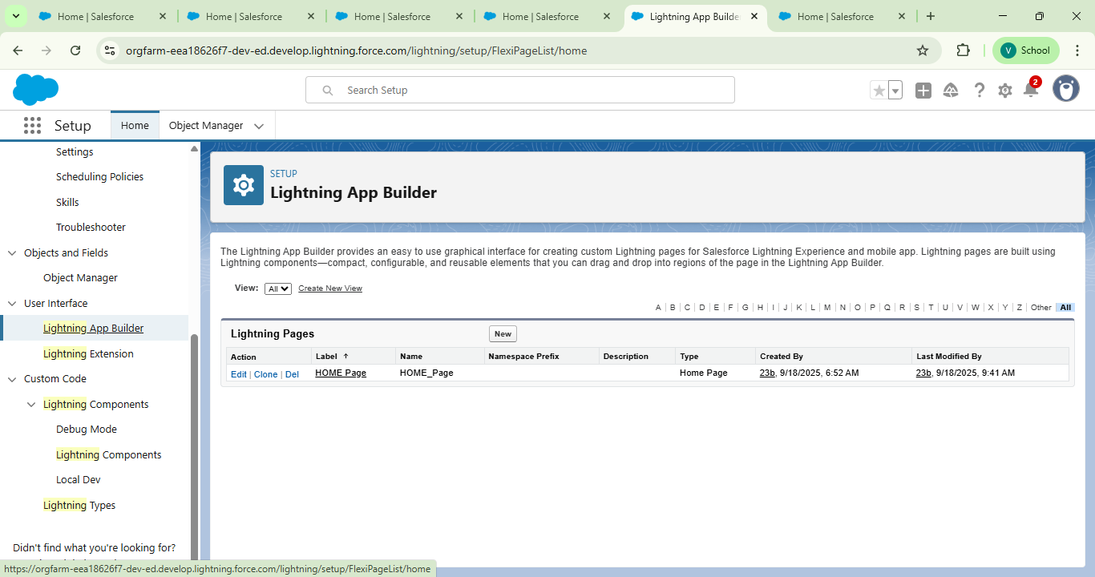

4**. Detailed Steps to Solution Design**

Building FoodConnect involved a structured and thoughtful approach to ensure the platform meets the needs of donors, volunteers, and recipients while leveraging the robust capabilities of Salesforce. Below is a step-by-step breakdown of the design and

implementation process:

**Step 1: Developer Account Setup**

● Registered for a Salesforce Developer account to create a dedicated environment for development and testing.

● Verified the account to unlock full access to Salesforce features, ensuring a smooth setup process.

**Step 2: Custom Object Creation**

● Used Salesforce Object Manager to design custom objects for Venues, Drop-Off Points, Tasks, Volunteers, and Execution Details.

● Configured fields such as text, numbers, dates, and relationships to capture all relevant data, ensuring each object reflects the real-world requirements of food distribution logistics.

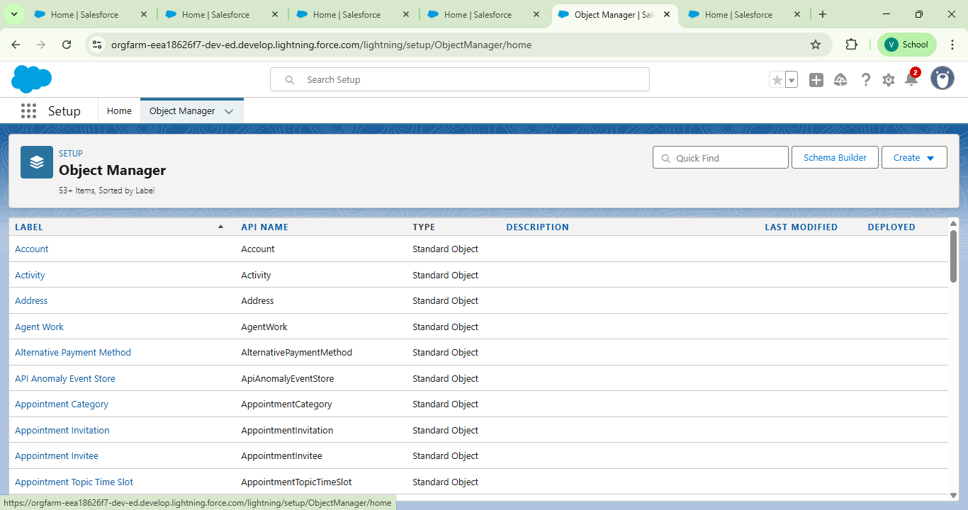

**Step 3: Custom Tabs for Navigation**

● Created custom tabs for each object, improving navigation and making it easier for users to access and manage data.

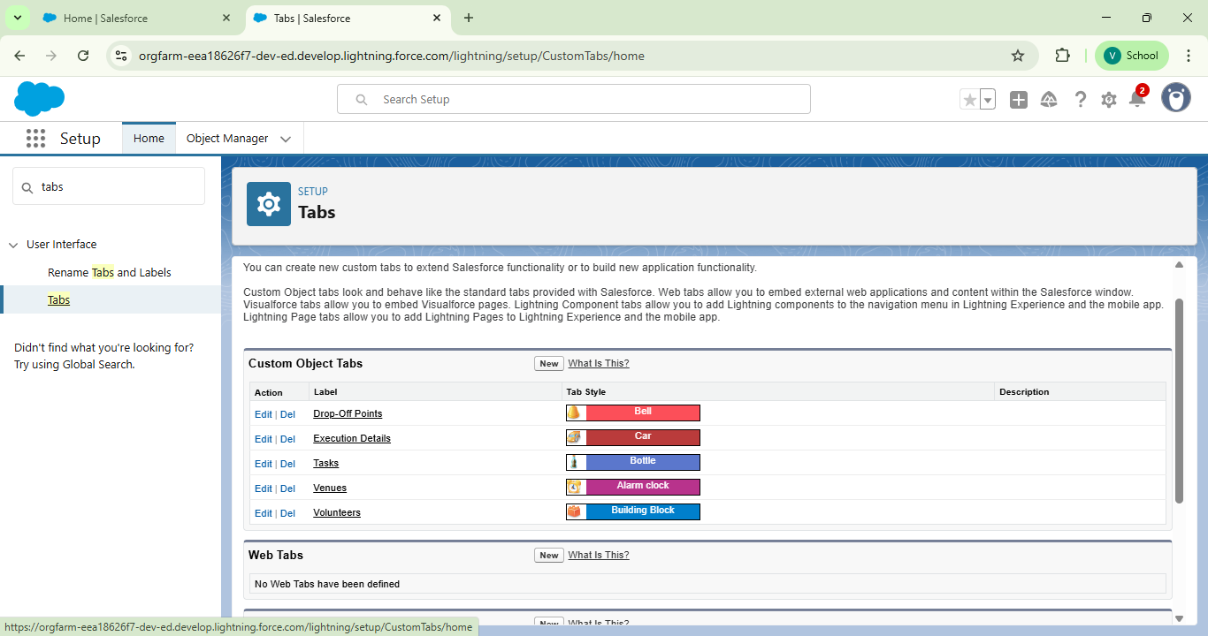

**Step 4: Lightning App Development**

● Developed a Lightning App named "FoodConnect" using Salesforce App Manager.

● Included essential navigation items like custom objects, reports, and dashboards to provide a user-friendly interface.

● Assigned user profiles to ensure role-based access and security

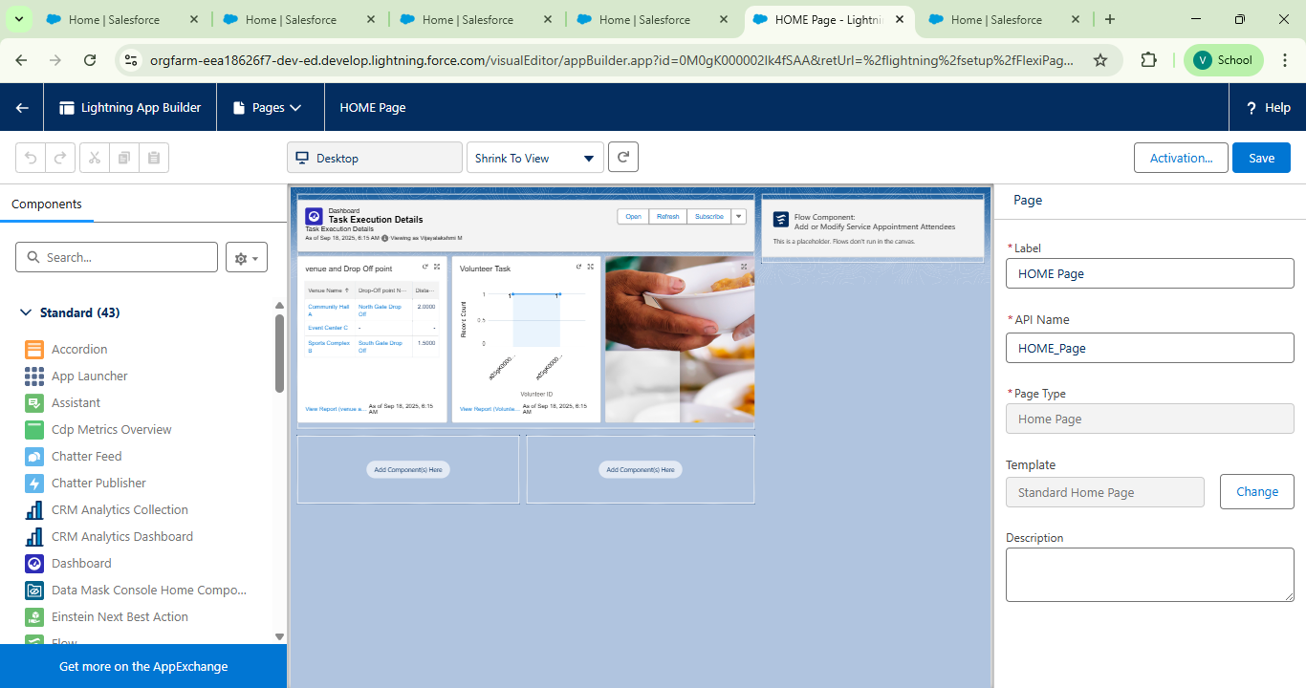

**Step 5: Establishing Data Relationships**

* Defined relationships between objects using Master-Detail and Lookup fields. Forexample:
* Master-Detail between Tasks and Execution Details to track completed
* activities.
* Lookup between Volunteers and Drop-Off Points to assign tasks efficiently.

**Step 6: Field Configuration**

* Configured fields for each custom object to capture data accurately. For instance:
* Venue: Name, Address, Capacity, Contact Information.
* Tasks: Description, Due Date, Assigned Volunteer.
* Volunteers: Contact Details, Availability

**Step 7: Flow Design**

● Designed a guided screen flow to simplify the process of entering Venue information.

● Automated record creation to ensure data accuracy and reduce manual errors.



**Step 8: Trigger Implementation**

● Developed Apex triggers to enhance automation, such as calculating distances between venues and volunteers.

● These triggers help assign tasks based on proximity, improving logistical efficiency



**Step 9: User Management and Permissions**

● Set up user profiles for administrators, volunteers, and other stakeholders.

● Configured permissions to ensure secure and role-appropriate access to data and functionalities.

**Step 10: Reporting and Dashboards**

● Created custom report types to analyze key metrics, such as volunteer participation, task completion rates, and food distribution impact.

● Built interactive dashboards to visualize data trends and provide actionable insights, empowering stakeholders to make informed decisions.

**Testing and Validation**

To ensure the FoodConnect solution functions seamlessly and meets all project requirements, a thorough testing and validation process was implemented. This approach focused on verifying both the technical and user-facing aspects of the system.

**1. Unit Testing**

● Objective: Validate the functionality of individual components, such as Apex triggers, workflows, and custom objects.

● Actions: Tested forms for venues, tasks, and drop-off points to ensure accurate data capture and validation.

○ Verified data storage and retrieval processes for volunteers, ensuring that all records were consistent and error-free.

○ Confirmed the proper execution of automated calculations, such as distance-based task assignments.

**2. User Interface Testing**

● Objective: Ensure the system is intuitive and user-friendly for all stakeholders, including donors, volunteers, and administrators.

● Actions:

○ Conducted extensive testing across all pages to confirm responsive design andseamless navigation.

○ Verified that reports and dashboards displayed accurate and up-to-date data in an easily interpretable format.

○ Ensured compatibility across various devices, with a focus on mobile accessibility for field agents.

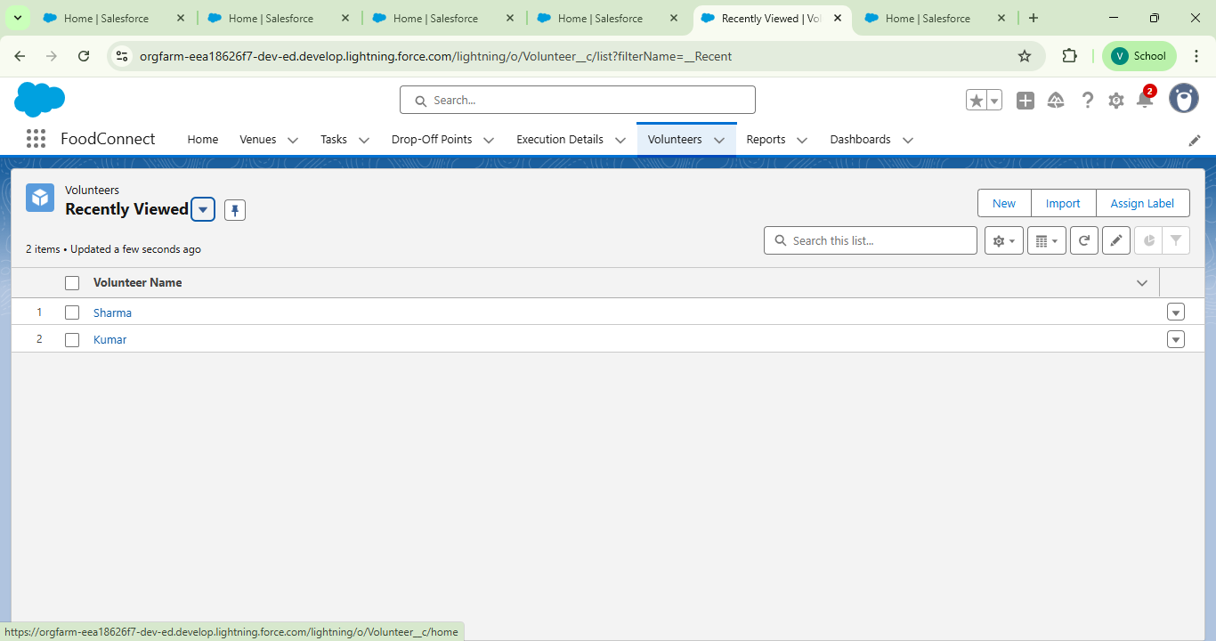

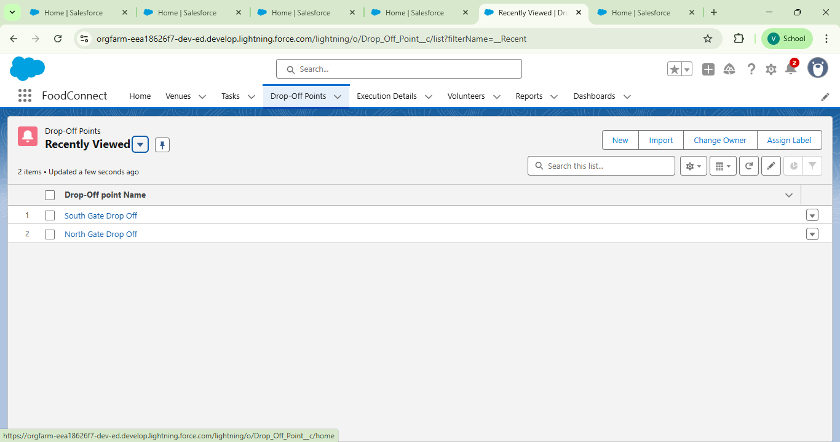

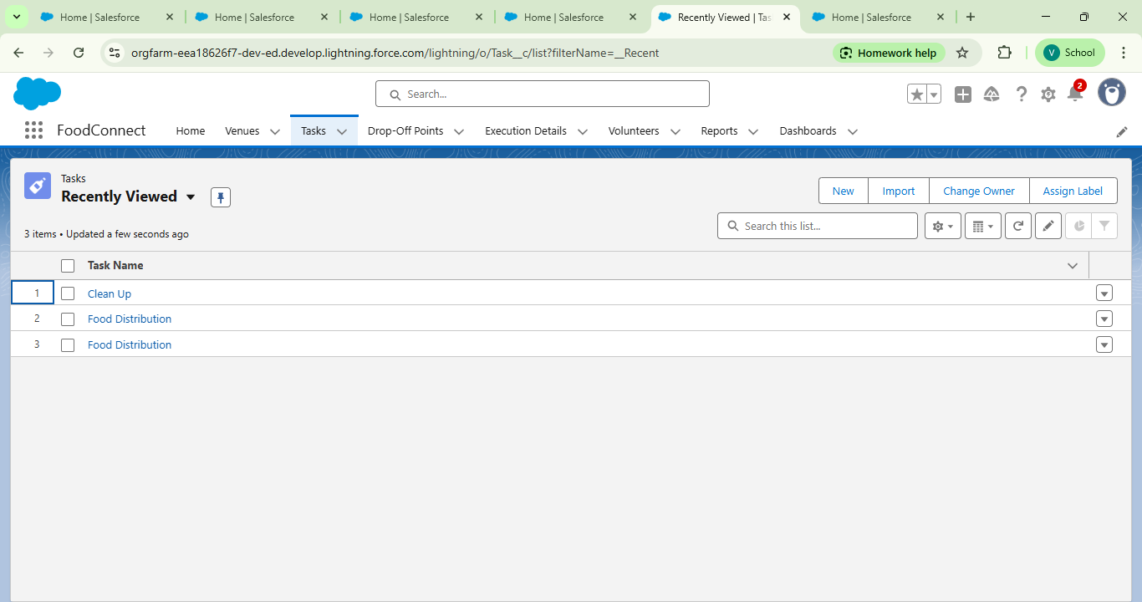

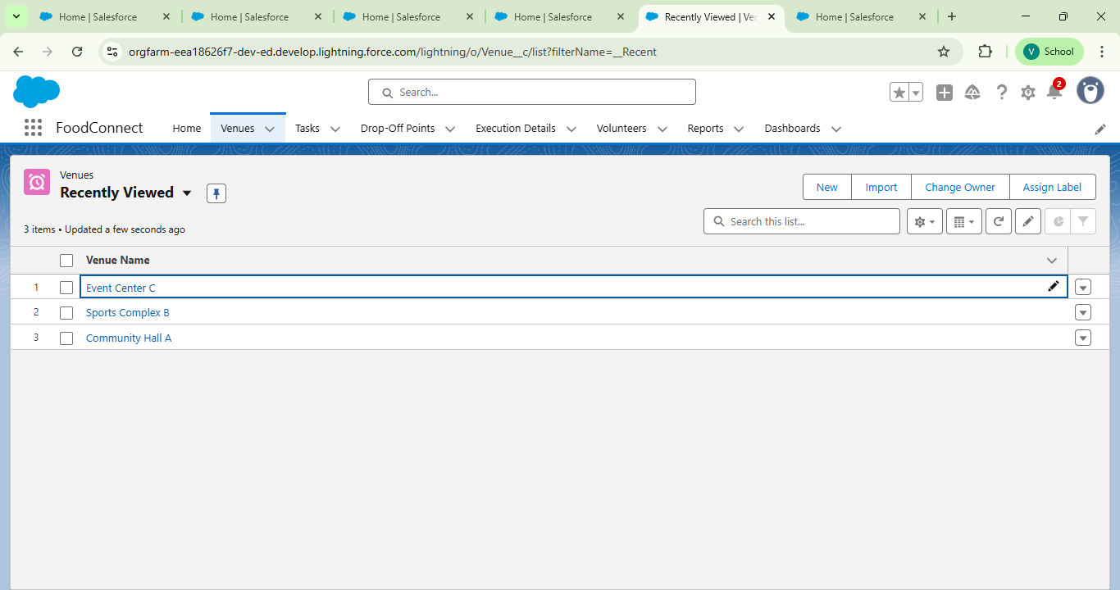

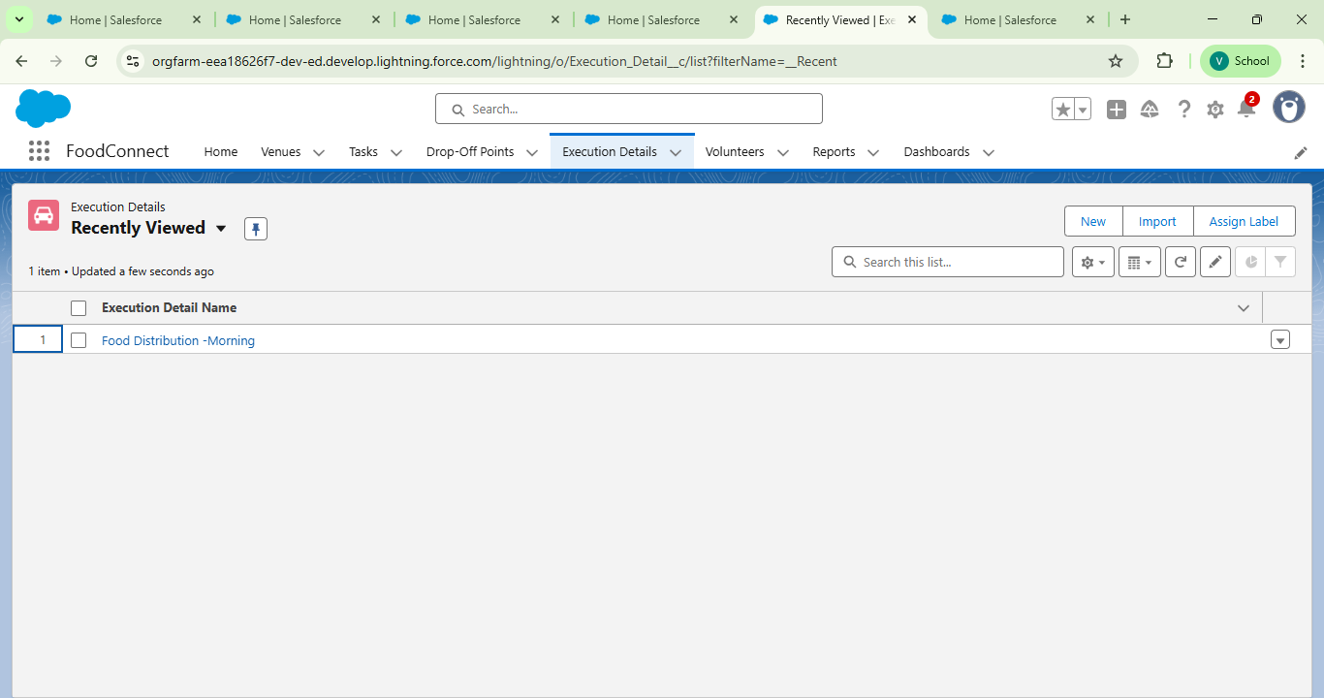

**6.Key Scenarios Addressed by Salesforce in the Implementation Project**

The FoodConnect project leverages Salesforce's capabilities to address a variety of realworld scenarios, ensuring efficient food redistribution and volunteer management. Below are the key scenarios tackled during the implementation: Salesforce can handle during the implementation.

**1. Efficient Management of Food Donation Venues**

● Scenario: A donor provides surplus food, and the details of the donation venue need to be recorded accurately.

● Salesforce Solution: Custom objects and fields were created to capture critical venue details, including name, address, capacity, and contact information, ensuring seamless record-keeping and accessibility.

**2. Task Assignment and Tracking for Volunteers Scenario:**

Volunteers need to be assigned tasks based on their availability and proximity to venues or drop-off points.

● Salesforce Solution: Using Master-Detail relationships and Apex triggers, tasks are automatically assigned to the most suitable volunteers, and progress is tracked in real-time through the Tasks object.

**3. Coordination of Food Drop-Off Points**

● Scenario: Food needs to be delivered to designated drop-off points efficiently and reliably.

● Salesforce Solution: Drop-Off Points were managed as a custom object, with

detailed fields for location, capacity, and operational hours, enabling smooth

coordination and tracking.

**4. Volunteer Engagement and Management**

● Scenario: Volunteers need to view their assignments, update their availability, and track their contributions.

● Salesforce Solution: A Volunteers object with a user-friendly interface allows

volunteers to manage their profiles and view task details, enhancing engagement and retention.

**5. Real-Time Communication and Notifications**

● Scenario: Stakeholders require updates on task assignments, delivery schedules, or any changes in plans.

● Salesforce Solution: Automated workflows and notifications ensure that all

participants are informed promptly, reducing delays and misunderstandings.

**6. Data Integrity and Reporting**

● Scenario: Stakeholders need to analyze the impact of food distribution efforts and identify areas for improvement.

● Salesforce Solution: Custom report types and dashboards provide actionable

insights into task completion rates, volunteer participation, and food distribution metrics, ensuring data-driven decision-making.

**7. Automation of Logistical Calculations Scenario**: Volunteers need to be assigned to venues or drop-off points based on proximity to minimize travel time and enhance efficiency.

● Salesforce Solution: Apex triggers calculate distances between venues and

volunteers, automating task assignments and optimizing logistics.

**8. Secure and Role-Based Data Access**

● Scenario: Different stakeholders require access to specific information based on their roles.

● Salesforce Solution: Profiles, sharing rules, and public groups ensure that users only access data relevant to their roles, maintaining security and confidentiality.

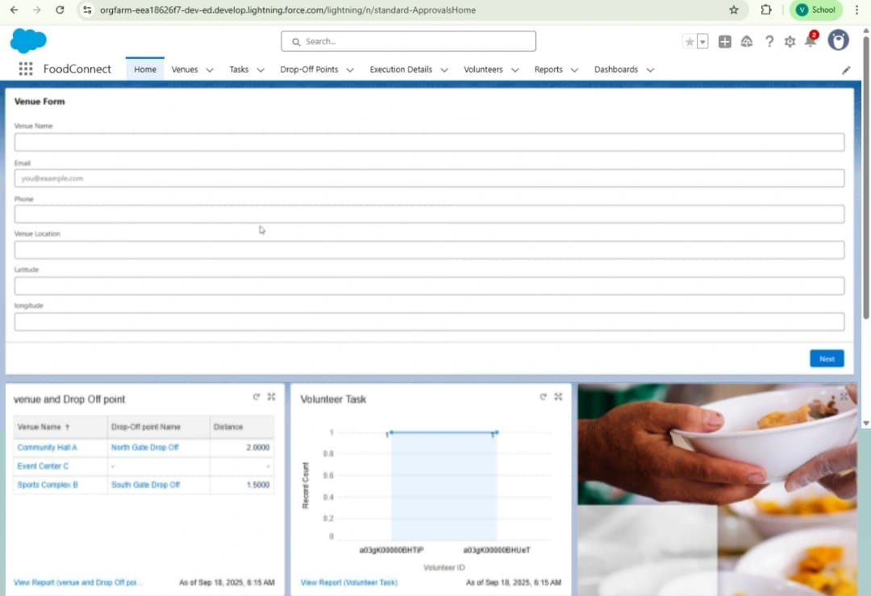

**7. Conclusion**

Summary of Achievements:

The FoodConnect project successfully delivered a comprehensive solution to address food waste and hunger by leveraging the power of Salesforce technology. Key

accomplishments include:

● Streamlined Food Distribution: Developed a robust system to manage thecollection, allocation, and delivery of surplus food to underserved communities.

● Enhanced Volunteer Management: Implemented efficient task assignment and tracking mechanisms to optimize volunteer engagement and contributions.

● Data-Driven Insights: Created detailed reports and dashboards, providing

actionable insights into food redistribution metrics, volunteer participation, and overall impact.

● User-Friendly Interface: Designed an intuitive Lightning App, ensuring a seamless experience for all users, including donors, volunteers, and administrators.

● Operational Efficiency: Automated workflows and triggers to reduce manual effort,improve accuracy, and ensure timely execution of tasks.

